***Instituto Politecnico Nacional***

**Escuela Superior de Cómputo**

# 

Práctica 1

**Instrumentation**

Group: 3CM14

Members:

* Bocanegra Heziquio Yestlanezi
* Martínez Cruz José Antonio
* López Reyna Bryan Ricardo

Teacher

Alcántara Méndez Alberto Jesús

# 

Index

Introduction 3

Measurement system 3

Data acquisition 4

Data signal conditioning 4

Data processing 4

Data distribution 4

Range or scope 4

Error 4

Resolution 5

Accuracy 5

Precision 5

Measurement uncertainty 5

Objetive 6

Material 6

Development 7

Error calculation 7

bench multimeter 7

hand-held multimeter. 8

Circuit 2 9

bench multimeter 2 10

handheld multimeter 10

Conclution 11

*Bocanegra Heziquio Yestlanezi* 11

*Martínez Cruz José Antonio* 11

López Reyna Bryan Ricardo 11

Bibliography 12

# Introduction

An important concept in general instrumentation is that of measurement, which is a standardized quantity of a certain physical magnitude, many times we have used instruments to measure from a ruler or meter, a weight, among others, likewise, electronics count with a large number of elements to measure physical magnitudes that otherwise would be almost impossible for man to know [1].

An instrument is a device that is built, specifically designed, and often refined through the method of trial and error, to help in a certain area, if we focus on measuring instruments, we can say that its area is the measurement of physical magnitudes. Instrumentation refers to the techniques, equipment and methodologies that are used to improve the perception of human beings, when we refer to electronic instrumentation, we speak of dealing with the measurement of any type of physical magnitude, the conversion of this to electrical magnitudes, and likewise of its treatment and conditioning to provide this information in an understandable way [1].

Every physical magnitude that we can measure is considered a variable, this variable presents a behavior in its magnitude with respect to time, usually this magnitude is transformed into its electrical equivalent, usually voltage, this is known as a signal and through from it we can observe the behavior of the physical magnitude of interest [1]. On some occasions the nature of a variable and its respective signal may be the same, on other occasions not, in general they are usually classified into two groups which are:

**Analog:** They can take infinite values ​​in a certain range.

**Digital:** These unlike analog, these take finite values.

## Measurement system

A measurement system describes the entire process through which a physical process must go through in order to be presented in an understandable way to an observer, or to another control system, the result of the measurement can be objective (independent of the observer) or empirical (based on experimentation). A measurement system could be summarized in some key elements and processes, mainly there is the transducer that oversees translating a physical magnitude into an electrical magnitude, this electrical magnitude goes through conditioning and finally a visualization of the physical magnitude is presented:

Figure 1 Data Acquisition System

Data acquisition**:** In this process, the physical quantity is transformed into its respective electrical signal, this is done through a sensor or transducer device [2]

Data signal conditioning**:** In general, the acquired data is not ready to be processed, so a conditioning prior to processing is performed:

* Amplification: Used to adapt the signal to optimal voltage levels before it is processed and to reduce noise.
* Filtering: It consists of eliminating a certain band of frequencies from the signal, it is a way of eliminating parts of the signal that are not desired.
* Linearization: It is to obtain an output signal that varies linearly with the variable to be measured.
* Signal conversion: It is used when it is required to go from one type of electrical variation to another, such as resistance to voltage, voltage to current or voltage to frequency [2].

Data processing**:** It consists of the selection and manipulation of data, in order to carry out a certain procedure with certain values ​​ [2].

Data distribution: Is to show, present the data to an observer or transmit it to another system [2].

The terms described later may be a guide to identify the characteristics of the process control instruments that are being used. The values ​​corresponding to these terms are typically found in the data sheets, in the specifications section of this [3].

## Range or scope

The range or scope is defined as the set of values ​​of the measured variable that are included within the upper and lower limits of the instrument's measurement capacity [3].

## Error

The error is the algebraic difference between the value measured or transmitted by the instrument and the real value of the variable measured by a standard instrument [3]. The error is normally indicated as a percentage, known as the relative error, and is given by the following relationship:

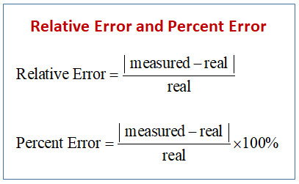

## Resolution

It is the minimum reliable value that can be measured on an instrument [3].

## Accuracy

Accuracy is the quality of an instrument to give readings close to the true value of the measured quantity. It is a function of the repeatability, resolution and calibration of the instrument [3].

## Precision

Precision is the degree of agreement between a series of determinations obtained by repeating the measurement under the same or different conditions and is expressed as the relative standard deviation (dispersion) or the coefficient of variation. The smaller the standard deviation, the better the precision. Accuracy is a function of repeatability and resolution [3].

When you want to obtain the maximum precision of the instrument at a certain point of the scale, it can be calibrated only for this working point. Manufacturers usually specify it for the entire range [3].

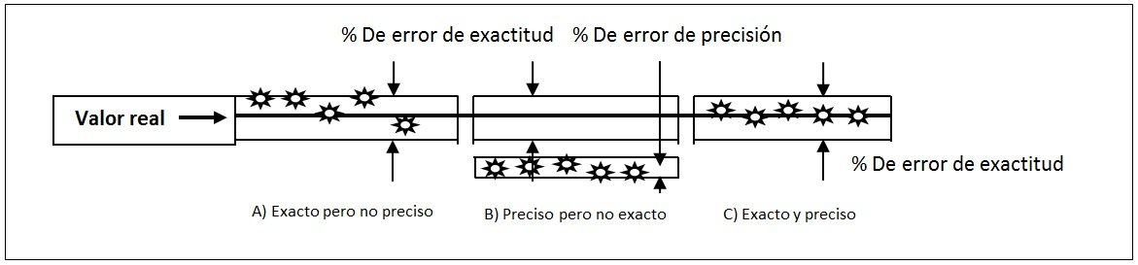

*Figure 2 Difference between precision and accuracy*

## Measurement uncertainty

The measurement uncertainty is the statistical distribution of the results that can be reasonably attributed to the true value of the measured magnitude [3].

**Dead zone**

# The dead zone is the field of values of the operational variable that does not vary the indication or the output signal of the instrument; that is, when faced with changes in the magnitude of the operational variable, the instrument does not produce responses. It is given as a percentage of the scope of the measurement [3].

# Objetive

At the end of the practice, the student will learn how to handle the errors in the measuring instruments, in order to find the most accurate possible value of the variable in question.

# Material

|  |  |
| --- | --- |
| Resistors 2.2 k y 330 ohms | Protoboard |
| handheld digital multimeter | Potentiometer 10 k |
| Variable source VCD |  |
| 4 Banana plug – Banana |  |
| 2 Banana plug – Caimán |  |

Table 1 Material

For each multimeter calculate:

* Resolution,
* Range. Bench multimeter: 10k, hand multimeter: 20k.
* Minimum variation.
* - Sensitivity.

# Development

## **Error calculation**

Use 2 multimeters, bench and handheld. Perform 10 measurements with each multimeter.

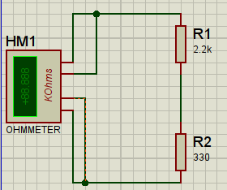Determine the absolute error.

Ilustration 1 Circuit error calculation

## **bench multimeter**

|  |  |  |  |  |
| --- | --- | --- | --- | --- |
| Measure (xi) | Frequency (fi) | Xi*fi | ea= X’-xi | ea*fi |
| 2.486KΩ | 3 | 7.458Ω | 0.00039 | 0.00117 |
| 2.487KΩ | 3 | 7.461Ω | -0.00061 | -0.00183 |
| 2.4861KΩ | 2 | 4.9722Ω | 0.00029 | 0.00058 |
| 2.4865KΩ | 1 | 2.4865Ω | -0.00011 | -0.00011 |
| 2.4862KΩ | 1 | 2.4862Ω | 0.00019 | 0.00019 |

Table 2 Bench multimeter circuit 1

X’=∑(xi*fi/n)=24.8639/10=2.48639KΩ

Ea=∑(X’-xi/n)=0.00388/10=0.000388KΩ

## **hand-held multimeter.**

|  |  |  |  |  |
| --- | --- | --- | --- | --- |
| Medida(xi) | Frecuencia(fi) | Xi*fi | ea= X’-xi | ea*fi |
| 2.48KΩ | 2 | 4.96Ω | 0.015 | 0.03 |
| 2.47KΩ | 2 | 4.94Ω | 0.025 | 0.05 |
| 2.52KΩ | 2 | 5.04Ω | -0.025 | -0.05 |
| 2.50KΩ | 1 | 2.5Ω | -0.005 | -0.005 |
| 2.51KΩ | 2 | 5.02Ω | -0.015 | 0.03 |
| 2.49KΩ | 1 | 2.49Ω | 0.005 | 0.005 |

Table 3 Hand - held multimeter circuit 1

X’=∑(xi*fi/n)=24.95/10=2.495KΩ X’= mean (average, considered as the actual measurement)

Ea=∑(X’-xi/n)=0.17/10=0.017KΩ Ea= Absolute inaccuracy

## Circuit 2

10 k potentiometer.

Set to 6.7 k

Use 2 multimeters, bench and hand-held. Make 10 measurements with each multimeter.

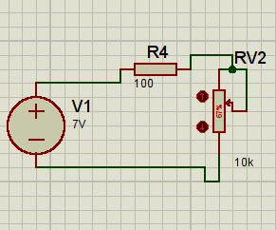

Ilustration 2 Circuit 2

## bench multimeter 2

|  |  |  |  |  |
| --- | --- | --- | --- | --- |
| Medida(xi) | Frecuencia(fi) | Xi*fi | ea= X’-xi | ea*fi |
| 6.08v | 3 | 18.24v | -0.0031 | -0.0093 |
| 6.071v | 1 | 6.071v | 0.0059 | 0.0059 |
| 6.079v | 2 | 12.158v | -0.0021 | -0.0042 |
| 6.075v | 1 | 6.075v | 0.0019 | 0.0019 |
| 6.078v | 1 | 6.078v | -0.0011 | -0.0011 |
| 6.07v | 1 | 6.07v | 0.0069 | 0.0069 |
| 6.077v | 1 | 6.077v | -0.0001 | -0.0001 |

Table 4 Bench multimeter circuit 2

X’=∑(xi*fi/n)=60.769/10=6.0769v

Ea=∑(X’-xi/n)=0.00388/10=0.00294v

## handheld multimeter

|  |  |  |  |  |
| --- | --- | --- | --- | --- |
| Medida(xi) | Frecuencia(fi) | Xi*fi | ea= X’-xi | ea*fi |
| 6.09v | 1 | 6.09v | 0.751 | 0.751 |
| 7.4v | 1 | 7.4v | -0.559 | -0.559 |
| 7.45v | 1 | 7.45v | -0.609 | -0.609 |
| 7.51v | 2 | 15.02v | -0.669 | -1.338 |
| 7.5v | 1 | 7.5v | -0.659 | -0.659 |
| 6.69v | 1 | 6.69v | 0.151 | 0.151 |
| 6.08v | 2 | 12.16v | 0.761 | 1.522 |
| 6.1v | 1 | 6.1v | 0.661 | 0.661 |

Table 5 Hand - held multimeter circuit 2

X’=∑(xi*fi/n)=68.41/10=6.841v

Ea=∑(X’-xi/n)=6.25/10=0.625v

# Conclution

## *Bocanegra Heziquio Yestlanezi*

At the time of the internship I could see that it was necessary to recover the knowledge previously acquired in subjects of other semesters such as circuits and analog electronics, although they were two relatively easy circuits, being absent from the laboratory and physical practices for two years, caused that some knowledge was forgotten, because everything was through simulations.

In the practice we could observe that it did not have many voltage variations, nor in the resistance, although the measurement was done quickly, even so we were able to observe some digits change and we could write them down.

## *Martínez Cruz José Antonio*

It can be thought that physical devices such as multimeters show exact values in each of their measurements, but it is very important to note that in real environments the results obtained in a multimeter will vary as many times as one makes measurements and even when said devices are of Much better quality and relatively new. This may go unnoticed, but companies take into consideration these values in which the measurements vary and are mentioned in their developed products, since like all components used, these have worn and their measurement precision will change. This may be insignificant for taking voltage in a home, but already in an industrial environment where the margin of error is needed to be very small, it is necessary to know that of the measurement devices.

## López Reyna Bryan Ricardo

It had been many years since I saw this topic, that of error measurement, personally it is a bit tedious for me, however I understand its importance for the manufacture of machinery and mechanical, electronic and digital devices; At the time we were developing the practice we remembered some basic concepts of circuits, but we had a major technical problem.

# Bibliography

|  |  |
| --- | --- |
| [1] | G. V. Ordaz, Medición y Control de Procesos Industriales, Mexico: Instituto Politécnico Nacional,, 2006. |
| [2] | I. Mexico, Apuntes Curso Instrumentación Básica de Procesos Industriales, Mexico, 2017. |
| [3] | A. C. Sole, Intrumentación Industrial, Barcelona: Marcombo, 2014. |

Ilustration 1 Circuit error calculation 7

Ilustration 2 Circuit 2 9

Table 1 Material 6

Table 2 Bench multimeter circuit 1 7

Table 3 Hand - held multimeter circuit 1 8

Table 4 Bench multimeter circuit 2 10

Table 5 Hand - held multimeter circuit 2 10